Lecture 6
DESCRIBING A PLACE

Descriptions are "word pictures." You tell how something looks, feels, smells,
tastes, and sounds. You need to become a sharp observer and notice many small
details so that you can write a good word picture. When you write a description, you tell what something-a person, an object, or a place-looks like.

There are two keys to writing good descriptions:
1. Use space order to organize your description.
2. Use lots of descriptive details.

Space order
Imagine that you are standing in the doorway of your classroom. How would y
describe the room to someone who has never seen it? Here are some possibilities
• You might start at the left side of the doorway and work your way
around the room in a clockwise direction to the right side, ending at the
doorway again.
• You might start at the front of the room and go from front to back,
first describing the chalkboard, the teacher's desk, and the area around
the teacher's desk. Then you might describe the students' desks in the
center of the room, and finally the walls and/or windows at the back
and sides of the room.
This kind of organization is called space order. Here are other kinds of sp
order that you can use to write a description:

top to bottom ↓
bottom to top ↑
right to left ←
left to right →
far to near
near to far
outside to inside >
inside to outside <

The refrigerator in the picture is described in the model paragraph on the next
page. As you read the model, look for phrases that tell you the location of things.
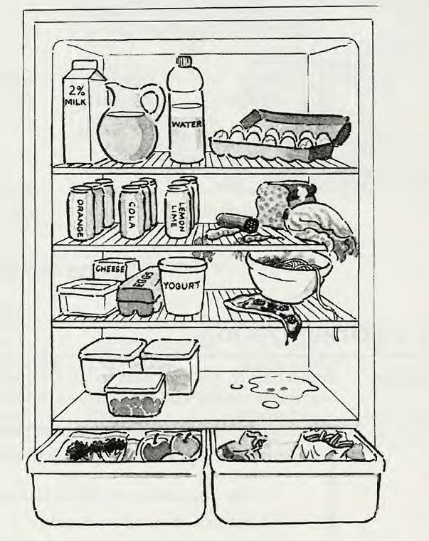
MODEL
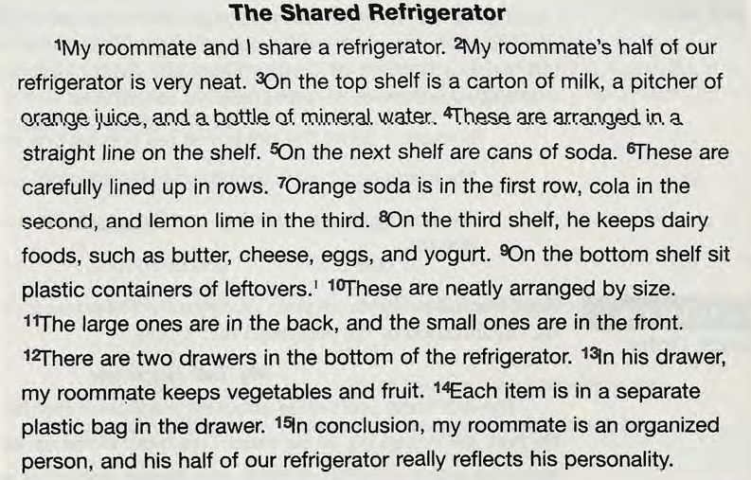

Topic and Concluding Sentences for Descriptive Paragraphs

The topic part of a topic sentence for a paragraph of description usually names
the person, place, or thing to be described. The controlling idea part usually gives
a general impression (beautiful, neat, messy, interesting, unusual, crowded, busy,
noisy, and so on. Here are some examples of topic sentences for paragraphs of
description.
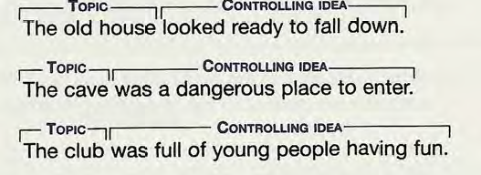

The concluding sentence of a description may repeat the idea stated in the
topic sentence. In the model paragraph, the writer used different words to repeat
the idea that the roommate's side of the refrigerator is neat. It may also give
the writer's opinion or feeling about the topic. Here are other examples of
concluding sentences for paragraphs of description.
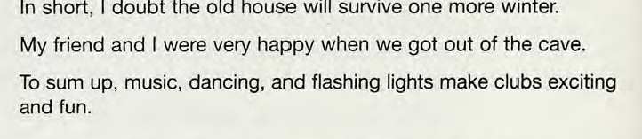

The second key to writing a good description is to use specific details. Your goal is to make your reader "see" what you have described. The way to do this is to use a lot of specific details. Specific means exact or precise. The opposite of specific is too general, or vague. The more specific you can be, the better your reader can see what you are describing.

Here are some examples:
Vague  a lot of money  a large house  a nice car  jogs a lot  a pretty face | Specific  $500,000  a six-bedroom, four-bathroom house  a Lexus  jogs three miles in the park every day  warm brown eyes, shining black hair,  and sparkling white teeth

ADJECTIVES
Adjectives describe nouns and pronouns. Adjectives tell what things (or people
look like, what kind they are, or how many of them there are. Adjectives answ
the questions: What kind? Which one? and How many?

what kind?  which one?  how many? | the old car with the broken window  the fourth chapter of the book, his car  twelve students, a few students

Here are some things to know about adjectives.

1. Adjectives always come in front of nouns, not after them.
twelve talented young musicians
2. Adjectives can also follow linking verbs.
be The children are happy.
seem You seem sad.
look Brides always look beautiful.
smell The cookies smell delicious.
taste Candy tastes sweet.
feel Silk feels smooth.
3. English has a kind of adjective called a compound adjective. A compound adjective is two or more words that function together as one word. A compound adjective often has a hyphen or hyphens between its parts.
ten-week semester part-time job two-year-old child
4. Adjectives are always singular. Never add s to an adjective, and never
use a plural word as an adjective.
big feet (not bigs feet)
terrible memories (not terribles memories)
Be especially careful when a compound adjective containing a number
comes before a noun.
a six-foot wall
a five-dollar bill
a two-year-old child
Of course, when words such as foot, dollar, and year are nouns, they can
be plural.
The wall is six feet high.
The book costs five dollars.
The child is two years old.
5. Nouns can be adjectives.
the English book
some tennis balls
a shoe store
the Japanese students
6. Proper adjectives (adjectives referring to nationalities, languages,
geographic places, and so on) are capitalized.
Egyptian custom
Spanish class
Cuban government
Asian languages
7. -ing and -ed words can be adjectives.
swimming pool
cooking class
sleeping baby
boring class
bored students
used car
broken heart
stolen money

ORDER OF ADJECTIVES

When you write several adjectives in a row, sometimes you must put them in a
particular order, and sometimes you can choose your own order depending on
the kind of adjective. One kind is called cumulative adjectives, and the other
kind is called coordinate adjectives.

Cumulative Adjectives

The poor little black dog

Coordinate Adjectives

The wet, cold, (and) hungry dog
The cold, wet, (and) hungry dog
The hungry, wet, (and) cold dog

Cumulative Adjectives
Cumulative adjectives always go before a noun. They must be in a particular
order. For example, you cannot write the little black poor dog; you must write
the poor little black dog. Do not put commas between cumulative adjectives.
The following list shows you the order of cumulative adjectives.

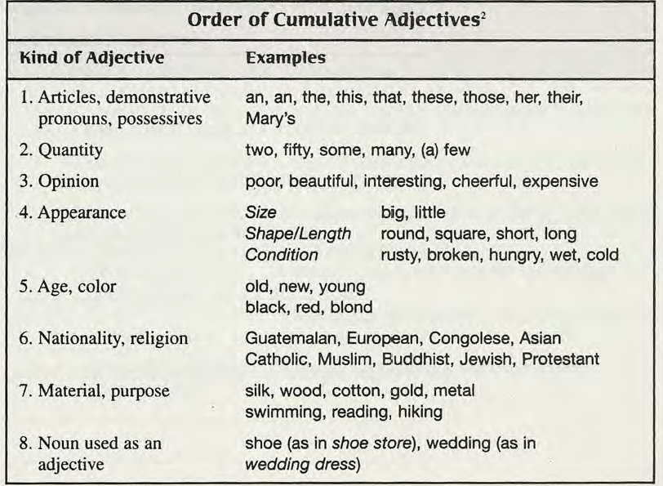

Coordinate Adjectives

Coordinate adjectives can go before a noun or after a linking verb. You can write
coordinate adjectives in any order, and you separate them from each other with
commas. Also,
• When coordinate adjectives come before a noun, you may put the word
and before the last one (but you don't have to).
• When two or more coordinate adjectives come after a linking verb, you
must put and before the last one.
Before a noun  (and optional)  After a linking verb  (and required) | A hungry, cold, wet dog sat outside our  front door.  A wet, cold, and hungry dog sat outside our  front door.  The dog was hungry, wet, and cold.
SENTENCE STRUCTURE
PREPOSITIONS
Prepositions are little words such as oj; to, from. in, and at. Most prepositions
are one word. A few prepositions are two words (because of) or three words (in
front of). Here is a list of common prepositions.
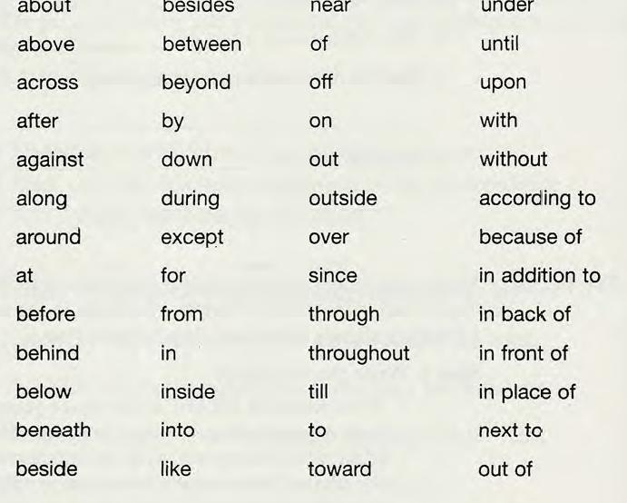

Some words, such as to, are sometimes prepositions and sometimes another
part of speech. Compare these two sentences.
Exaxmples
1. We went to the supermarket.
2. We wanted to buy some fruit.
In sentence 1, to is a preposition because it is followed by a noun (the
supermarket). In sentence 2, the word to is part of the infinitive verb phrase
to buy.
PREPOSITIONAL PHRSES
A preposition is usually combined with a noun or noun phrase to make aprepositional phrase, such as in the house or at six o'clock.
Some prepositional phrases answer the question where. These are prepositional
phrases of place. Prepositional phrases of place are useful in space-order
paragraphs to show the location of objects in a description.

on the desk
next to the window
under the bed
in front of the house
opposite the door
in the closet
in the middle of the room
in the distance

Other prepositional phrases answer the question when. These are prepositional
phrases of time. Prepositional phrases of time are useful in "how to" paragraphs
to give the order of the steps.

at last
after that
after class
on New Year's Day
before the test
upon arrival
in the morning
at midnight

Other prepositional phrases show possession:
(the father) of the bride
(the name) of my boss
(the colors) of the rainbow
(the president) of the company
Others describe or identify someone or something:
(the woman) with red hair
(the student) from Ecuador
(the man) in the blue shirt
(the car) with the flat tire

WRITING
Follow the steps in the writing process.
Step 1 Prewrite to get ideas.
• Use the prewriting technique that is most productive for you:
freewriting, clustering, or listing.
• Make an outline.
Step 2 Write the first draft.
• Write ROUGH DRAFT at the top of your paper.
• Begin your paragraph with a topic sentence that names the place an
gives a main idea about it. You can give its general size or conditio
or a general impression. Use an adjective, such as big, small,
luxurious, messy, beautiful, plain, wild, mysterious, or comfortable.
• Use space order (right to left, top to bottom, far to near, and so on)
to organize your sentences. Use prepositional phrases to show the
order. Put some of the prepositional phrases at the beginning of the ·~
sentences.
• Write several sentences that give descriptive details. You can descri
objects, and you can also tell what people are doing in the place.
adjectives in your descriptive details.
• End your paragraph with a sentence that tells your feeling about
the place.
Step 3 Edit the first draft.
• Edit your paragraph with a partner as you have done in previous
chapters. Use the Reader's Response 4B and Writer's Self-Check
on pages 204 and 205.
Step 4 Write the final copy.
• Write a neat final copy of your paragraph to hand in to your teacher
Your teacher may also ask you to hand in your prewriting, your
outline, and your other drafts.

